**Question 1**: Before evaluating the effect of an experiment, it is important to make sure that the experiment was executed correctly. Check whether the test and control groups are probabilistically equivalent on their observables?

a. More specific, compare the averages of the income, gender and gamer variables in the test and control groups. You should also report the % difference in the averages. Compute its statistical significance.

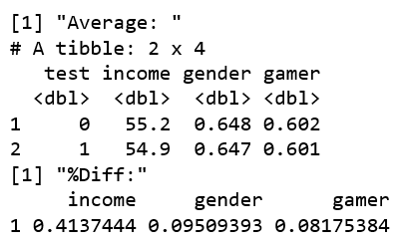

The average income of control group is $55.2K, while the average income of test income is $54.9K. 64.8% of control group are male, while 64.7% of the test group are male. There are 60.2% of the control group are gamers, while the test group has 60.1%. The percentage difference in the averages are 0.41% in income, 0.095% in gender, and 0.08% in gamer.

*T-test for income:*

Null Hypothesis: There is no significant difference between test group income and control group income.

Alternative Hypothesis: There is significant difference between test group income and control group income.

Significance Level: 5%

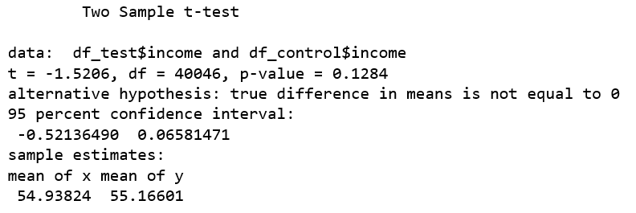

Conclusion: At 5% significance level, there is no significant difference between test group income and control group income.

*Proportion test for gender:*

Null Hypothesis: There is no significant difference between test group gender and control group gender

Alternative Hypothesis: There is significant difference between test group gender and control group gender

Significance Level: 5%

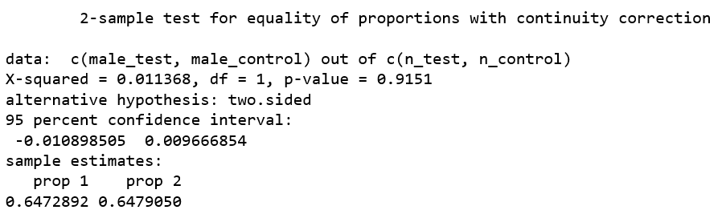

Conclusion: At 5% significance level, there is no significant difference between test group gender and control group gender

*Proportion test for gamer:*

Null Hypothesis: There is no significant difference between test group gamer and control group gamer

Alternative Hypothesis: There is significant difference between test group gamer and control group gamer

Significance Level: 5%

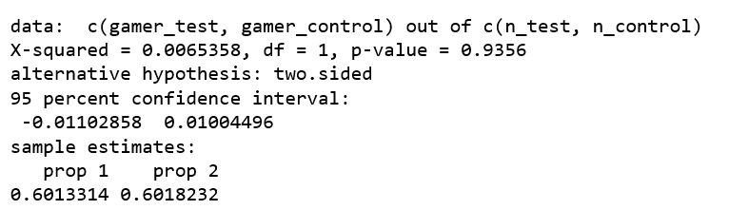

Conclusion: At 5% significance level, there is no significant difference between test group gamer and control group gamer

b. Briefly comment on what these metrics tell you about probabilistic equivalence for this experiment.

With the t-test and proportion test that compare the difference of two groups, all tests’ p-values are much larger than 0.05, the significance level we set, which means that there is no difference between two groups in income, gender, and gamer. Overall, for the current dataset, the test group and control group are probabilistic equivalent.

c. If you had run this type of analysis BEFORE executing an experiment and found a large difference between test and control groups, what you should do?

If I can run this test before the experiment and find the two groups are not probabilistic equivalent, I will re-design the test group and control group and make sure that they are matched.

d. (Open/Ended Question) If you had millions of consumers, your “classic” statistical significance tests would not work (this is because the number of samples is used to compute those classic statistical tests). Do some research online and propose what significance test would you do in case you had “big data”?

The article "Too Big to Fail: Large Samples and the p-Value Problem" (Lin, 2013) reviewed several ways to dealing with the "big data” situation. Usually, people would decrease the significant threshold to adjust the test and report the confidence interval. Some people also notice the audience about the "big data" issue. "A critical evaluation of the current “p‐value controversy”" (Stefan, 2017) suggests people to calculate the effect size rather than use p-value.

Mingfeng Lin, Lucas Jr., H. C., & Shmueli, G. (2013). Too Big to Fail: Large Samples and the p-Value Problem. Information Systems Research, 24(4), 906–917. <https://doi.org/10.1287/isre.2013.0480>

Wellek, S. (2017). A critical evaluation of the current “p‐value controversy”. Biometrical Journal, 59(5), 854–872. <https://doi.org/10.1002/bimj.201700001>

**Question 2**: Evaluate the average purchase rates in the test and control for the following groups. For each comparison, report the average purchase rate for the test, average purchase rate for the control and the absolute difference (not the % difference) between the test and control.

1. Comparison 1: All customers

The purchase rate of the control group is 3.62%, while the purchase rate of the test group is 7.68%. The absolute difference is 4.06%. From the result, test group has higher purchase rate than the control group.

1. Comparison 2: Male vs Female customers

For the male, the purchase rate of control group is 3.72%, while the test group is 7.46%. The absolute difference is 3.74%.

For the female, the purchase rate of control group is 3.44%, while the test group is 8.09%. The absolute difference is 4.65%.

From the result, gender does not affect the purchase rate a lot.

1. Comparison 3: Gamers vs Non-Gamers Customers

For the gamer, the purchase rate of control group is 3.54%, while the test group is 10.4%. The absolute difference is 6.91%.

For the non-gamer, the purchase rate of control group is 3.74%, while the test group is 3.51%. The absolute difference is 0.23%.

From the result, the test improves the purchase rate of gamers.

1. Comparison 4: Female Gamers vs Male Gamers

For the male gamers, the purchase rate of control group is 3.73%, while the test group is 10.1%. The absolute difference is 6.41%.

For the female gamers, the purchase rate of control group is 3.2%, while the test group is 11%. The absolute difference is 7.81%.

From the result, the test has effect on both male gamers and female gamers.

**Question 3**: Assess the expected revenue in the test vs. control for the following comparisons:

1. Comparison 1: All customers

Test Group Expected Revenue: $ 80925 Control Group Expected Revenue: $ 16237.5

The promotion increased the expected revenue.

1. Comparison 4: Female Gamers vs Male Gamers

For the male gamer, the expected revenue of control group is $6,525, while the test group is $41,438.

For the female gamer, the expected revenue of control group is $3,038, while the test group is $24,750.

This promotion increased revenue no matter the gamer is female or male.

**Question 4**: Based on your previous answers, provide a brief recommendation to your management team summarizing the expected financial outcome for Game-Fun.

1. Should Game-Fun run this promotion again in the future? If no, explain why. If yes, should Game-Fun offer it to all customers or a targeted segment.

According to our findings, Game-Fun should run this promotion in the future. Since we found that this promotion is work on gamers rather than non-gamers, Game-Fun should offer it to gamers. Also, there is not difference of the effect on female gamers and male gamers, so the promotion should focus on all gamers.